EE5356 LAB Assignment

Edge detection:
Take a (256×256) or (512×512) 8-bit/pel image and perform the following edge detection operations:
1. Sobel Operator
2. Prewitt Operator
3. Robel operator
4. Laplacian of Gaussian
5. Canny’s Edge Detection
Procedure:
1) Read an image (any size up to 512x512).
2) Perform the edge detection using the techniques mentioned above.
3) Apply proper thresholding method and observe the difference in the image before and after applying thresholding.
4) Compare the final image obtained using default MATLAB Edge detection operator.

References:
1) Anil K Jain, “Fundamentals of Digital Image Processing”, Prentice Hall Publication, pp 347-357
2) Rafael C. Gonzalez and Richard E.Woods, “Digital image
processing”, Prentice Hall Publication, Third Edition pp 706 - 723

Theory for Edge Detection:
Edge detection is a terminology in image processing and computer vision, particularly in the areas of feature detection and feature extraction, to refer to algorithms which aim at identifying points in a digital image at which the image brightness changes sharply or more formally has discontinuities. The extraction of edges or contours from a two dimensional array of pixels (a gray-scale image) is a critical step in many image processing techniques. A variety of computations are available which determine the magnitude of contrast changes and their orientation.
There are many ways to perform edge detection. However, the majority of different methods may be grouped into two categories:

- Gradient: The gradient method detects the edges by looking for the maximum and minimum in the first derivative of the image.

- Laplacian: The Laplacian method searches for zero crossings in the second derivative of the image to find edges. An edge has the one-dimensional shape of a ramp and calculating the derivative of the image can highlight its location. Suppose we have the following signal, with an edge shown by the jump in intensity below:
Suppose we have the following signal, with an edge shown by the jump in intensity below:
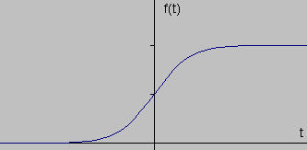
If we take the gradient of this signal (which, in one dimension, is just the first derivative with respect to t) we get the following:
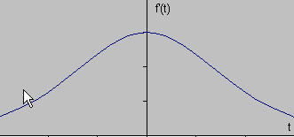

Clearly, the derivative shows a maximum located at the center of the edge in the original signal. This method of locating an edge is characteristic of the “gradient filter” family of edge detection filters and includes the Sobel method. A pixel location is declared an edge location if the value of the gradient exceeds some threshold. As mentioned before, edges will have higher pixel intensity values than those surrounding it. So once a threshold is set, you can compare the gradient value to the threshold value and detect an edge whenever the threshold is exceeded. Furthermore, when the first derivative is at a maximum, the second derivative is zero. As a result, another alternative to finding the location of an edge is to locate the zeros in the second derivative. This method is known as the Laplacian and the second derivative of the signal is shown below:

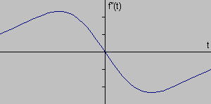

Sobel Operator:
The Sobel operator performs a 2-D spatial gradient measurement on an image and so emphasizes regions of high spatial frequency that correspond to edges. Typically it is used to find the approximate absolute gradient magnitude at each point in an input grayscale image.
Mathematically, the operator uses two 3×3 kernels which are convolved with the original image to calculate approximations of the derivatives - one for horizontal changes, and one for vertical. If we define A as the source image, and Gx and Gy are two images which at each point contain the horizontal and vertical derivative approximations, the computations are as follows:
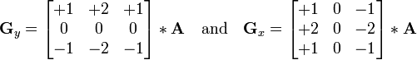
where * here denotes the 2-dimensional convolution operation.
The x-coordinate is here defined as increasing in the "right"-direction, and the y-coordinate is defined as increasing in the "down"-direction. At each point in the image, the resulting gradient approximations can be combined to give the gradient magnitude, using:
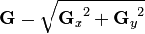
Using this information, we can also calculate the gradient's direction:
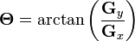
where, for example, Θ is 0 for a vertical edge which is darker on the left side.
The result of the Sobel operator is a 2-dimensional map of the gradient at each point. It can be processed and viewed as though it is itself an image, with the areas of high gradient (the likely edges) visible as white lines. The following images illustrate this, by showing the computation of the Sobel operator on a simple image.

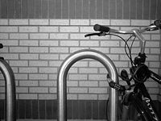  Grayscale image of a brick wall & a bike rack | 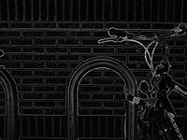  Normalized sobel gradient image of bricks & bike rack
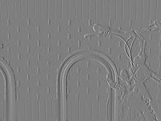  Normalized sobel x-gradient image of bricks & bike rack | 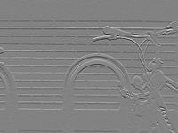  Normalized sobel y-gradient image of bricks & bike rack
Prewitt Operator:
Mathematically, the operator uses two 3×3 kernels which are convolved with the original image to calculate approximations of the derivatives - one for horizontal changes, and one for vertical. If we define as the source image, and and are two images which at each point contain the horizontal and vertical derivative approximations, the latter are computed as:
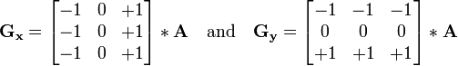

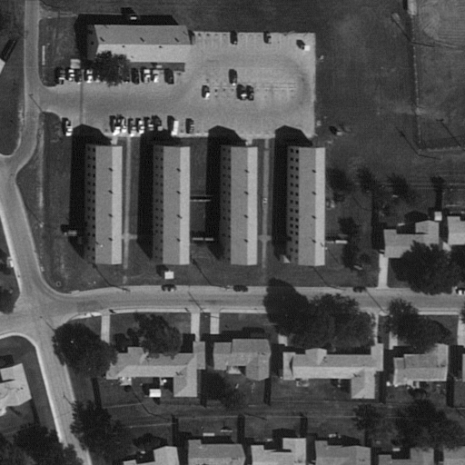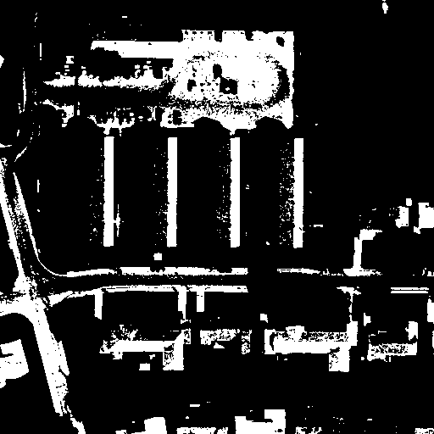
Raw B/W image of Fort Hood, TX Result of Prewitt + Threshold
Robel operator:
The Roberts Cross operator performs a simple, quick to compute, 2-D spatial gradient measurement on an image. It thus highlights regions of high spatial frequency which often correspond to edges. In its most common usage, the input to the operator is a grayscale image, as is the output. Pixel values at each point in the output represent the estimated absolute magnitude of the spatial gradient of the input image at that point.
In computer vision, the Roberts' Cross operator is one of the earliest edge detection algorithms, which works by computing the sum of the squares of the differences between diagonally adjacent pixels. This can be accomplished by convolving the image with two 2x2 kernels:
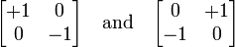

Comparison of Edge detection Algorithm
Original Sobel
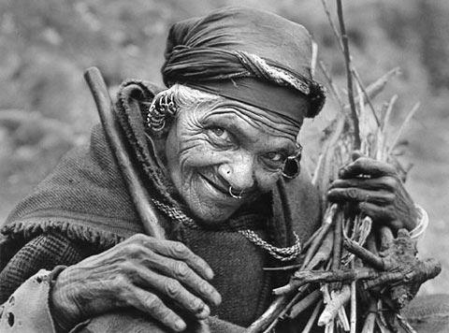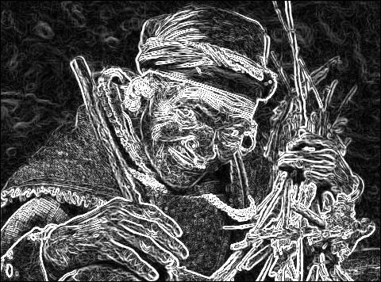
Prewitt Robert
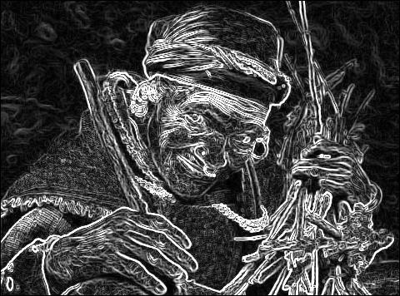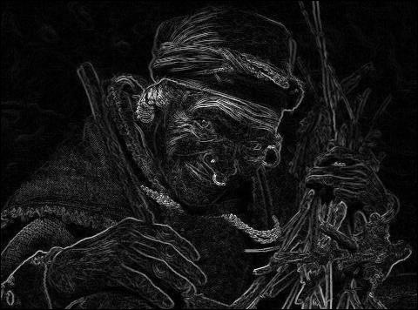

Laplacian of Gaussian:
The Laplacian is a 2-D isotropic measure of the 2nd spatial derivative of an image. The Laplacian of an image highlights regions of rapid intensity change and is therefore often used for edge detection. The Laplacian is often applied to an image that has first been smoothed with something approximating a Gaussian Smoothing filter in order to reduce its sensitivity to noise. The operator normally takes a single graylevel image as input and produces another graylevel image as output.
The Laplacian L(x,y) of an image with pixel intensity values I(x,y) is given by:
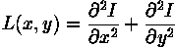
Since the input image is represented as a set of discrete pixels, we have to find a discrete convolution kernel that can approximate the second derivatives in the definition of the Laplacian. Three commonly used small kernels are shown.
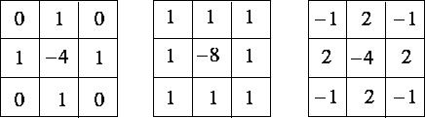
Because these kernels are approximating a second derivative measurement on the image, they are very sensitive to noise. To counter this, the image is often Gaussian Smoothed before applying the Laplacian filter. This pre-processing step reduces the high frequency noise components prior to the differentiation step.
In fact, since the convolution operation is associative, we can convolve the Gaussian smoothing filter with the Laplacian filter first of all, and then convolve this hybrid filter with the image to achieve the required result. Doing things this way has two advantages:
- Since both the Gaussian and the Laplacian kernels are usually much smaller than the image, this method usually requires far fewer arithmetic operations.
- The LoG (`Laplacian of Gaussian') kernel can be precalculated in advance so only one convolution needs to be performed at run-time on the image.
The 2-D LoG function centered on zero and with Gaussian standard deviation has the form:
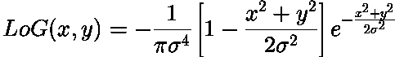
and is shown
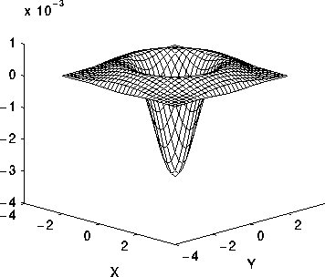
Note that as the Gaussian is made increasingly narrow, the LoG kernel becomes the same as the simple
Laplacian Laplacian of Gaussian
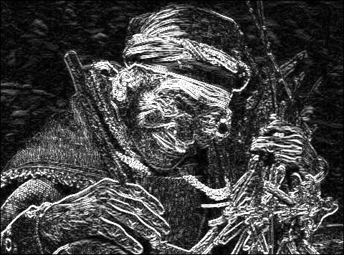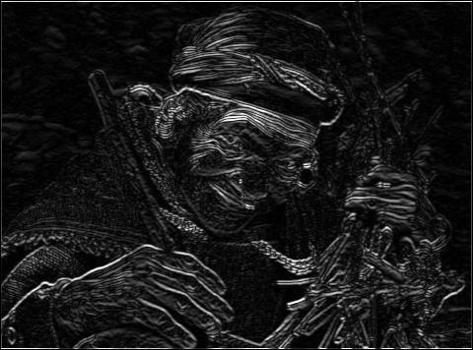
Canny’s Edge Detection Algorithm
Canny’s approach is based on three basic objectives:
1. Low error rate. All edges should be found, and there should be no spurious responses. That is, the edges detected must be as close as possible to the true edges.
2. Edge points should be well localized. The edges located must be as close as possible to the true edges. That is, the distances between a point marked as an edge by the detector and the center of the true edge should be minimum.
3. Single edge point response. The detector should return only one point for each true edge point. That is, the number of local maxima around the true edge should be minimum. This means that the detector should not identify multiple edge pixels where only a single edge point exists.
Based on these criteria, the canny edge detector first smoothes the image to eliminate and noise. It then finds the image gradient to highlight regions with high spatial derivatives. The algorithm then tracks along these regions and suppresses any pixel that is not at the maximum (nonmaximum suppression). The gradient array is now further reduced by hysteresis. Hysteresis is used to track along the remaining pixels that have not been suppressed. Hysteresis uses two thresholds and if the magnitude is below the first threshold, it is set to zero (made a nonedge). If the magnitude is above the high threshold, it is made an edge. And if the magnitude is between the 2 thresholds, then it is set to zero unless there is a path from this pixel to a pixel with a gradient above T2.
Step 1
In order to implement the canny edge detector algorithm, a series of steps must be followed. The first step is to filter out any noise in the original image before trying to locate and detect any edges. And because the Gaussian filter can be computed using a simple mask, it is used exclusively in the Canny algorithm. Once a suitable mask has been calculated, the Gaussian smoothing can be performed using standard convolution methods. A convolution mask is usually much smaller than the actual image. As a result, the mask is slide over the image, manipulating a square of pixels at a time. The larger the width of the Gaussian mask, the lower is the detector's sensitivity to noise. The localization error in the detected edges also increases slightly as the Gaussian width is increased. The Gaussian mask used in my implementation is shown below.
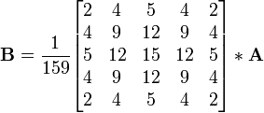
Step 2
After smoothing the image and eliminating the noise, the next step is to find the edge strength by taking the gradient of the image. The Sobel operator performs a 2-D spatial gradient measurement on an image. Then, the approximate absolute gradient magnitude (edge strength) at each point can be found. The Sobel operator uses a pair of 3x3 convolution masks, one estimating the gradient in the x-direction (columns) and the other estimating the gradient in the y-direction (rows). They are shown below:
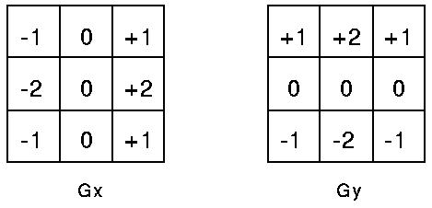
The magnitude, or edge strength, of the gradient is then approximated using the formula:
|G| = |Gx| + |Gy|
Step 3
The direction of the edge is computed using the. However gradient in the x and y directions, an error will be generated when sumX is equal to zero. So in the code there has to be a restriction set whenever this takes place. Whenever the gradient in the x direction is equal to zero, the edge direction has to be equal to 90 degrees or 0 degrees, depending on what the value of the gradient in the y-direction is equal to. If GY has a value of zero, the edge direction will equal 0 degrees. Otherwise the edge direction will equal 90 degrees. The formula for finding the edge direction is just:
Theta = invtan (Gy / Gx)
Step 4
Once the edge direction is known, the next step is to relate the edge direction to a direction that can be traced in an image. So if the pixels of a 5x5 image are aligned as follows:
x x x x x
x x x x x
x x a x x
x x x x x
x x x x x
Then, it can be seen by looking at pixel "a", there are only four possible directions when describing the surrounding pixels - 0 degrees (in the horizontal direction), 45 degrees (along the positive diagonal), 90 degrees (in the vertical direction), or 135 degrees (along the negative diagonal). So now the edge orientation has to be resolved into one of these four directions depending on which direction it is closest to (e.g. if the orientation angle is found to be 3 degrees, make it zero degrees). Think of this as taking a semicircle and dividing it into 5 regions.
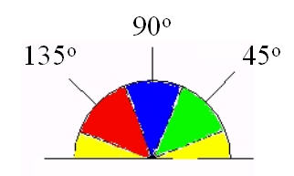
Therefore, any edge direction falling within the yellow range (0 to 22.5 & 157.5 to 180 degrees) is set to 0 degrees. Any edge direction falling in the green range (22.5 to 67.5 degrees) is set to 45 degrees. Any edge direction falling in the blue range (67.5 to 112.5 degrees) is set to 90 degrees. And finally, any edge direction falling within the red range (112.5 to 157.5 degrees) is set to 135 degrees.
Step 5
After the edge directions are known, nonmaximum suppression now has to be applied. Nonmaximum suppression is used to trace along the edge in the edge direction and suppress any pixel value (sets it equal to 0) that is not considered to be an edge. This will give a thin line in the output image.
Step 6
Finally, hysteresis is used as a means of eliminating streaking. Streaking is the breaking up of an edge contour caused by the operator output fluctuating above and below the threshold. If a single threshold, T1 is applied to an image, and an edge has an average strength equal to T1, then due to noise, there will be instances where the edge dips below the threshold. Equally it will also extend above the threshold making an edge look like a dashed line. To avoid this, hysteresis uses 2 thresholds, a high and a low. Any pixel in the image that has a value greater than T1 is presumed to be an edge pixel, and is marked as such immediately. Then, any pixels that are connected to this edge pixel and that have a value greater than T2 are also selected as edge pixels. If you think of following an edge, you need a gradient of T2 to start but you don't stop till you hit a gradient below T1.
Conclusion:
Performance of Edge Detection Algorithms:
- Gradient-based algorithms such as the Prewitt filter have a major drawback of being very sensitive to noise. The size of the kernel filter and coefficients are fixed and cannot be adapted to a given image. An adaptive edge-detection algorithm is necessary to provide a robust solution that is adaptable to the varying noise levels of these images to help distinguish valid image contents from visual artifacts introduced by noise.

- The performance of the Canny algorithm depends heavily on the adjustable parameters, σ, which is the standard deviation for the Gaussian filter, and the threshold values, ‘T1’ and ‘T2’. σ also controls the size of the Gaussian filter. The bigger the value for σ, the larger the size of the Gaussian filter becomes. This implies more blurring, necessary for noisy images, as well as detecting larger edges. As expected, however, the larger the scale of the Gaussian, the less accurate is the localization of the edge. Smaller values of σ imply a smaller Gaussian filter which limits the amount of blurring, maintaining finer edges in the image. The user can tailor the algorithm by adjusting these parameters to adapt to different environments.

- Canny’s edge detection algorithm is computationally more expensive compared to Sobel, Prewitt and Robert’s operator. However, the Canny’s edge detection algorithm performs better than all these operators under almost all scenarios.

Note: In the program, thresholding is done after the Edge Detection operations on trial and error basis to get a better match with the image obtained using the default MATLAB command.
Output:

Sobel Edge Detection

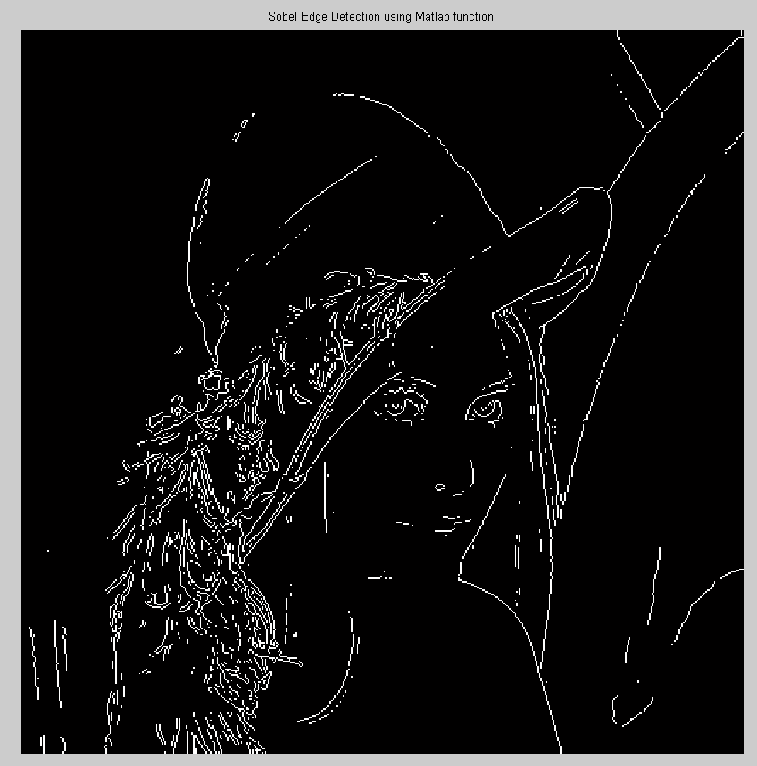
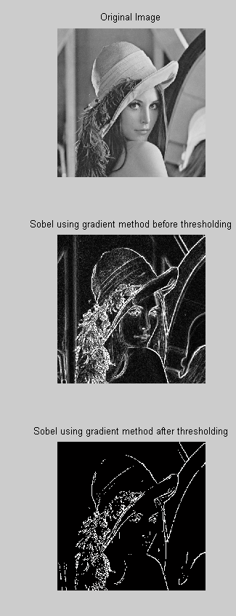
Prewitts Edge Detection

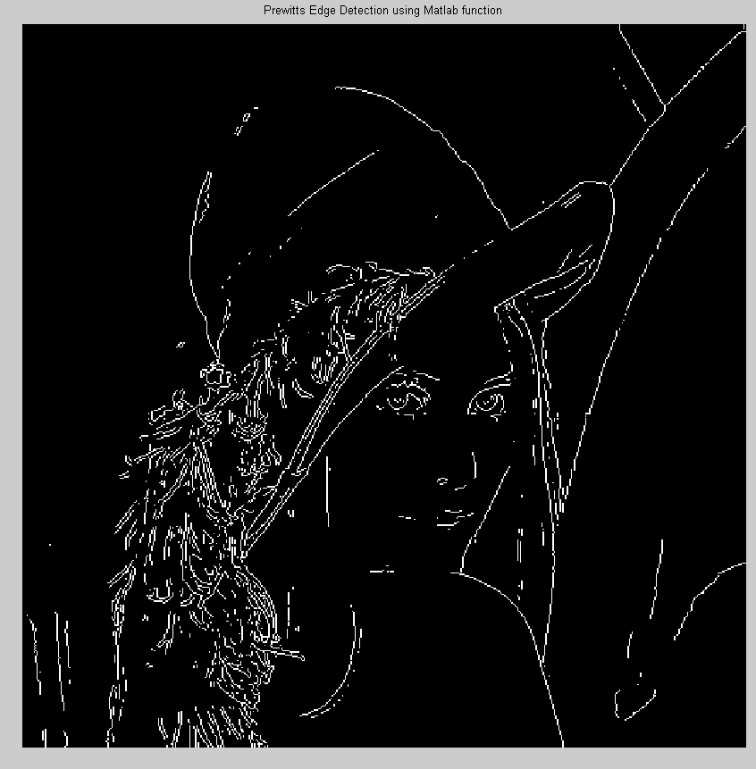

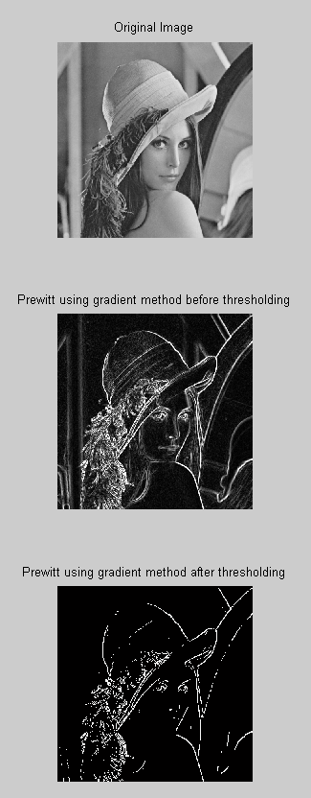
Roberts Edge Detection

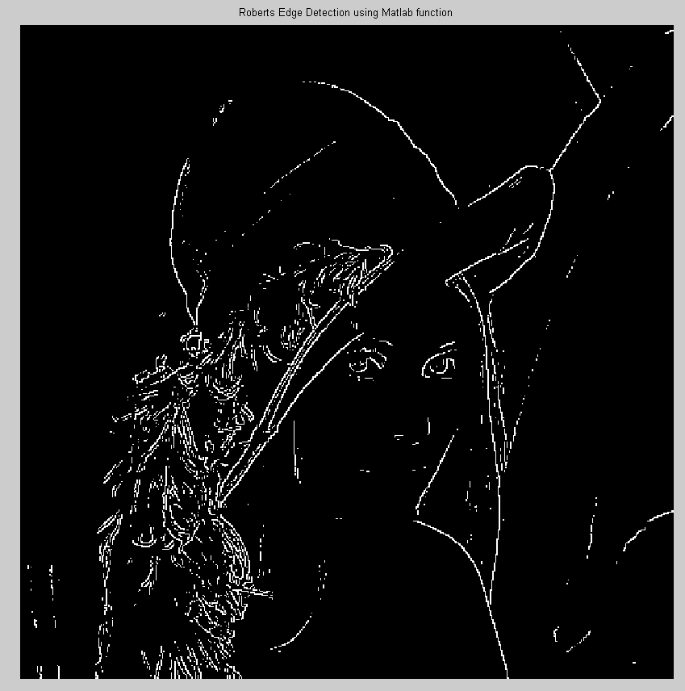

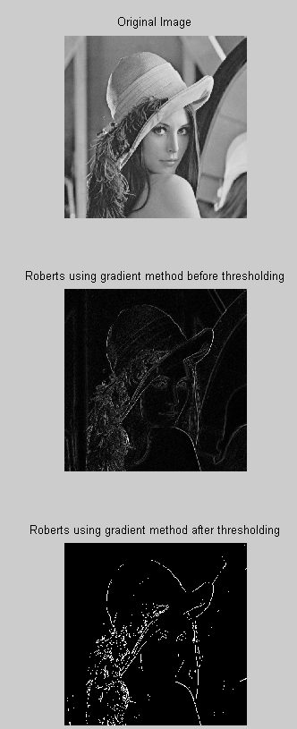

Laplacian Edge Detection:

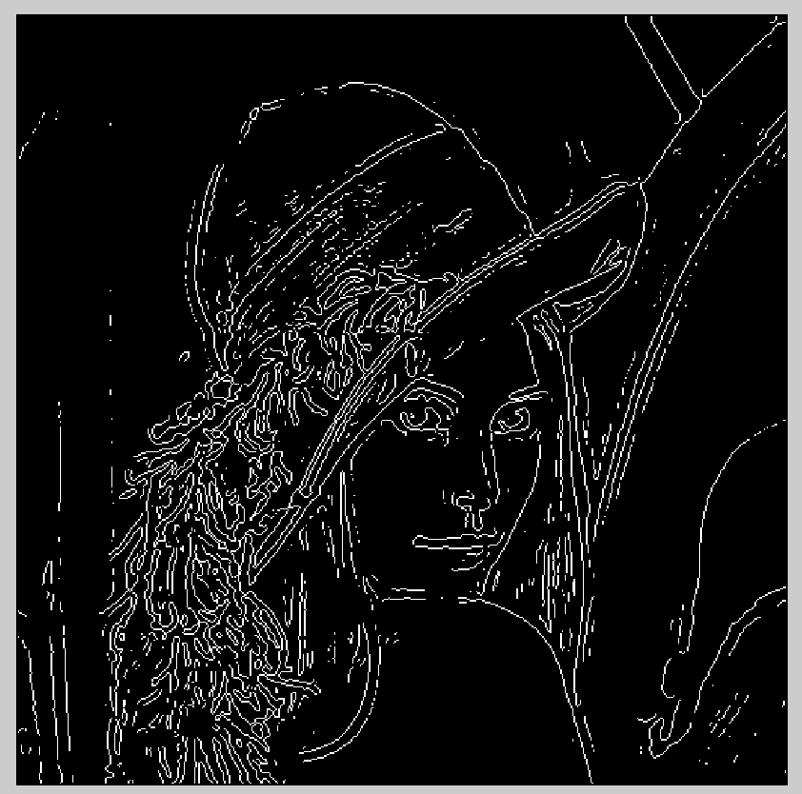

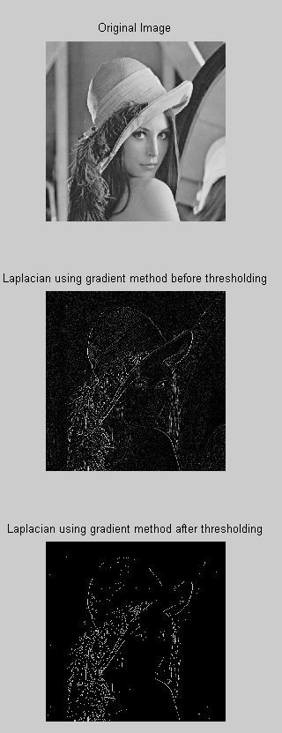
Canny Edge Detection
